Self and Peer assessment form for COM109 Coursework 2

Please assess your contribution to the preparation of the solution to the COM109 coursework in relation to that of your other team member.

Did each of you contribute equally? If so, each team member will be given an equitable apportioning of the marks. For non-equitable efforts, those contributing less than their fair share will receive a scaled mark accordingly.

Allocate a mark for each member of your team. Ensure that the marks together total 100.

Group ID (eg: subGroupA):

Peer Contribution Evaluation

Group Member Name | Student ID | Estimated Contribution (%)
 |  | 25%
 |  | 25%
 |  | 25%
 |  | 25%
Total |  | 100%

What particular responsibility/tasks did each team member undertake during the preparation of the assignment solution?
completed: (1) Gallery and Reviews page; (2) responsive CSS; (3) reservation validation; (4) Cookie Consent Banner; (5) navigation fixes; and (6) GitHub maintenance.
completed: (1) reservation page; (2) responsive design; (3) booking JavaScript and localStorage; (4) confirmation and receipt features; (5) link fixes; and (6) testing and GitHub maintenance.
completed: (1) Menu page; (2) responsive styling and filtering; (3) Admin Dashboard; (4) booking search and statistics; (5) CSV export; and (6) testing and GitHub maintenance.
completed: (1) Staff Portal Login; (2) shared style.css; (3) responsive CSS; (4) reusable utils.js; (5) resource and navigation fixes; and (6) testing and documentation, GitHub control.

Self-Assessment Checklist
Task | Yes / No
- Created HTML structure and web pages | Yes
- Styled the site using CSS (including responsiveness) | Yes
- Developed JavaScript functionality (animations, validation) | Yes
- Worked on form validation and user input handling | Yes
- Integrated accessibility features | Yes
- Managed version control (GitHub) | Yes
- Documented code and wrote report sections | Yes
- Debugged issues and tested functionalities | Yes
- Organised group meetings & coordinated tasks | Yes
- Packaged and submitted final assignment files | Yes

Repository Link: https://github.com/Satirtha7/Book-IT

Introduction
This report explains my effort in creating The Golden Leaf Restaurant Website that was a Client-Side Development group project. The main idea for the project was to produce a responsive and interactive website for a restaurant to promote their products, by giving their visitors the opportunity to look at their menu list through the website, view their photographs from the gallery area, read customers' feedback and even make a reservation online.
My main part of work has been developing a Gallery and Reviews page (rohit.html). I also created its responsive styling (rohit.css) of this page and added the client-side validation system (validation.js) for the reservation form. Besides that, I added and integrated the Cookie Consent Banner, fixed navigation to Homepage, linked CSS and JavaScript files, and helped to clean up and integrate the final project.
I regularly committed my code to the shared GitHub repository throughout the project, ensuring smooth and efficient collaboration among members and helping maintain continuous integration. What was mainly behind my work was the delivery of a user-friendly and professional website by focusing on responsive design, semantic HTML, well-structured CSS and client-side validation.
As a fine-dining restaurant theme "The Golden Leaf" our group thought of a great idea before touching any code. To meet the main needs of the briefing, we came up with gallery displaying, testimonials, and booking form. Our division of labor was very different as we divided ourselves per page or feature instead of technology, so each developer took care of complete HTML, CSS, and JS of the assigned area without being in different teams.
I focused my Gallery and Reviews work mainly on two points: making a visual representation of the restaurant and the guest's reviews so that they can cause a reservation. First, I was sketching a plan (masonry-style image grid + the review-card section) after which I decided to use CSS Grid for the gallery because of its flexibility in image sizes without the need for extra markup. I made a list of all the requirements (e-mail name date etc.) and the handling of error messages at different stages of validation for the form. It also meant that validation should be run both while the user types and after submitting so users would get the feedback as soon as the error appears and not at a wall of errors after they click "reserve". And, we wanted to add a Cookie Consent Banner which is non-interfering and just there if someone needs it. My main use of Git here was committing small parts which allowed my teammates and I to work on each feature (gallery display, cookie banner and validation field) as separated stages that were much easier to review as one big change.

Description of HTML Code for the Gallery and Reviews Page
My I mainly developed the Gallery and Reviews page (rohit.html) where we displayed the restaurant's ambiance and customer ratings to entice visitors to make online reservations. The opening of the page features standard HTML5 with meta tags indicating that a document uses UTF-8 encoding, sets the viewport to be responsive (that adapts to different device dimensions) and includes SEO details. I connected Google Fonts, Font Awesome, AOS (Animate On Scroll) and CSS files specific to the project to enhance the look and feel of the website and its functionality.
The page layout is based on structured HTML like headings articles sections and nav, which will make the code more manageable and accessible over time. The menubar consists of anchor links to key website elements. The Masonry-gallery class was applied to this section together with several gallery-item divs as content placeholders for the images. Accessibility was ensured by writing a text description of every image (alt). The scroll animation of each picture is handled by data-aos tags. We designed various image heights through large and tall CSS classes that visually enriched the entire layout.
The Reviews part is showing customers' opinions by repeating a review-card template which comprises a picture name rating, and comment of the reviewer. I added 'Reserve Your Table' button linking it to the booking page plus placing a floating AI Assistant button for a more intuitive user navigation and enhanced website browsing experience.
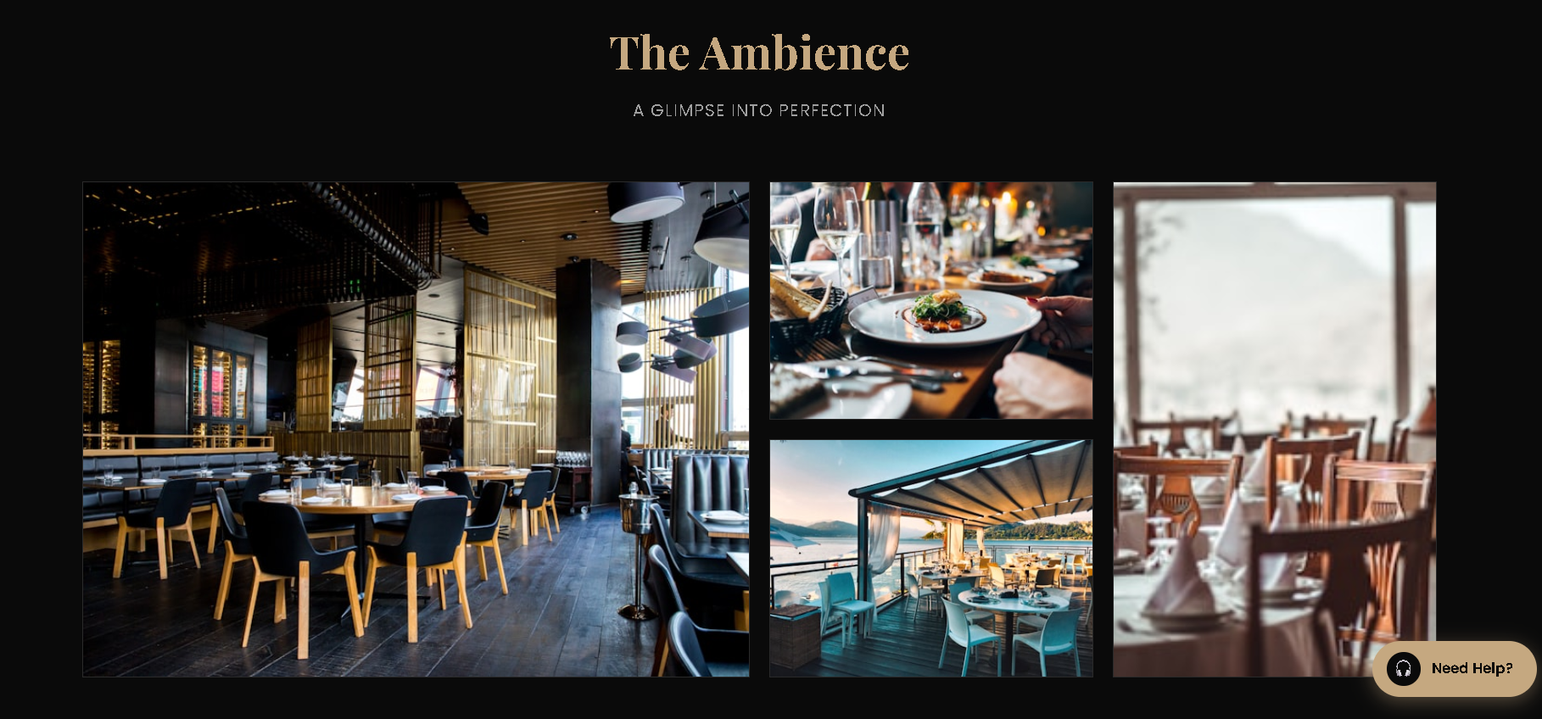
Figure 1. Insert screenshot of showing the Gallery section.

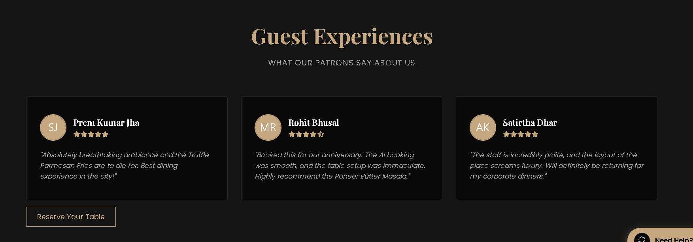
Figure 2. Insert screenshot of showing the Reviews section.

Description of CSS Code for the Gallery and Reviews Page
Once the website's HTML markup was complete, I created rohit.css to build a modern, visually attractive and responsive website layout aligned to the restaurant branding.
With the Grid display for the Gallery section and grid-template-columns: repeat(auto-fit, minmax(300px, 1fr)), the interface automatically adjusts itself to various screen sizes..large and.tall classes make selected images take up more than one row or column forming a masonry-style image gallery. As an extra, I put object-fit: cover to keep the images in their frames without scaling and distortions. In the hover effects I used transform: scale(1.1), filter: brightness(0.7) that together result in a visually smooth user interaction with the gallery's image.
In the Reviews section, a responsive layout with grid display was used for showing off the review cards, and the spacing was arranged in such a way that everything looked clean. The profile pictures were a little rounded, while the star ratings in the icon form were colored gold to ensure that the restaurant theme was always present visually through these features.
On top of that, I was also engaged in creating the Cookies Banner by making use of position: fixed so that it always stays at the bottom. The banner is hidden in the first place and then is being shown by the.show class that employs CSS transitions for a smooth sliding-up animation of the banner. Lastly, I used media queries to check if the gallery images, review cards and cookies banner continue to remain responsive and user friendly on mobile and tablet devices as well.
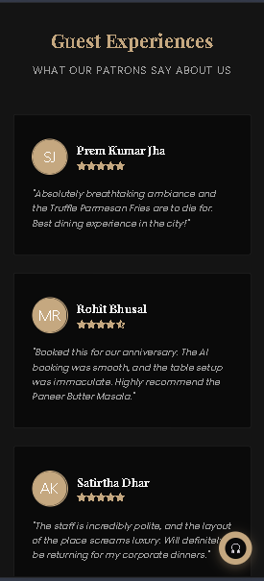
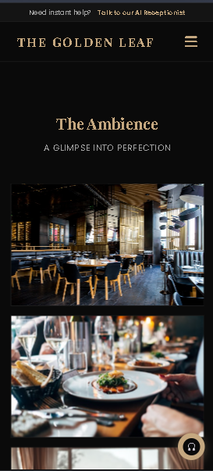
To sum up, my design and CSS code helped improve the site's responsiveness, consistency of design and overall quality of the browsing experience, while the code remained neat enough and re-usable.

Figure 3. Insert screenshot of showing responsive media queries

Description of JavaScript Code
Along with the front-end development, I integrated validation.js to check the reservation form right after the user fills out details but before the reservation is officially booked. Validation.js stops submission of data that doesn't meet the rules and gives users immediate indication of what's wrong.
This code waits for the page to load completely by using DOMContentLoaded event before it accesses the reservation form. Each input field with its validation rule and error message is stored in a fields object, keeping the code neat and allowing reuse. The script validates fields like Full Name, Phone Number Email Booking Date, Booking Time, NumberOfGuests, and Terms & Conditions. It employs Regular Expressions to check the correctness of the phone and email formats, doesn't allow a booking to be scheduled for earlier dates, limits the guests to 1, 10, checks for a valid time slot, and needs that the user has accepted the rules of the booking policy.
Error messages are created dynamically with accessibility attributes. input-valid and input-invalid are styles that visually show feedback. Validation takes place as a user types and again while submitting the form. preventDefault() and stopImmediatePropagation(), in the case when any of the form's fields is invalid, stop the booking process and shift attention to the first invalid field. Besides that, I added a Cookie Consent Banner. setCookie(), getCookie() and eraseCookie() functions help in cookie-related tasks whereas the Cookie Consent Banner is rendered by JavaScript after the page is loaded and hidden if the user clicks on Accept or Decline buttons.
Ultimately, such a method prevents the submission of wrong reservation data, increases quality of the database, supports accessibility and, at the same time, ensures better performance and user satisfaction.
Figure 4. Insert screenshot of the Cookie Consent Banner.

Testing and Validation
I tested every feature I built after implementation to make sure it functioned as expected in various browsers and screen sizes. The Gallery page was the focus of tests to check if its responsive CSS Grid layout and smooth hover animations really work. To make sure my form validation system displayed relevant error messages as well as stopping invalid submissions, I filled it up with bad emails, wrong phone number, past booking dates, empty fields and wrong number of guests. Eventually I checked that the Cookie Consent Banner was shown properly on first page view and it was closed if the user clicked either Accept or Decline.

Conclusion
On The Golden Leaf Restaurant Website, my main roles were front-end development and the client-side functionality. For Gallery and Reviews sections, I made use of semantic HTML5 code only, I came up with responsive design and used the latest CSS3 to achieve the look, and I coded strong JavaScript for client-side form validations. Besides these, I installed Cookie Consent Banner, fixed homepage navigation, hooked up CSS and JavaScript files into the site, fine-tuned responsive navigation, and I helped out cleaning up the project just before the group submission.
The Git commit history showcases that I was always on-site during the development phase. It is a timeline that shows how a feature started with the initial coding of it, then the polishing was done on it for better UX, and finally it was integrated with the rest of the system. Using semantic HTML, creating good responsive CSS, JavaScript validation on the browser side, and putting into practice a set of accessibility guidelines, I was able to contribute greatly to our group project by raising it to the level of a great, functional, and user-friendly professional restaurant website.

